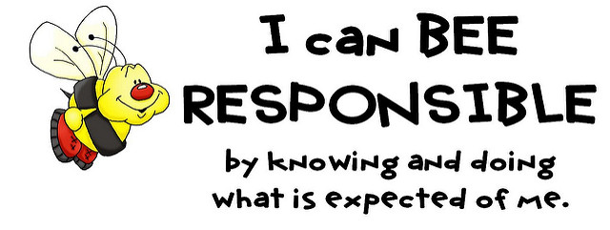

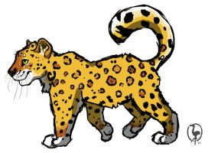

Welcome to Ms. Dunn 7th Grade Science Class

My name is Courtney Dunn. I was born and raised in Augusta, GA. I am the 7TH Grade Science Teacher here at Hornsby Middle School. I have Bachelor of Science degree in Sociology. I am presently working on a Master’s degree in Secondary Education at Grand Canyon University.

In the classroom, I plan to motivate my students to become lifelong learners in the field of Science. We will also conduct appropriate activities to demonstrate the subjects. Students will also be assigned homework and projects throughout the school year to demonstrate what we have learned.

**Course Description:** The **Seventh Grade Georgia Standards of Excellence**for science are designed to give all students the necessary skills for a smooth transition from elementary life science standards to high school biology standards. The purpose is to give all students an overview of common strands in life science including, but not limited to, diversity of living organisms, structure and function of cells, heredity, ecosystems, and biological evolution.

Seventh grade students keep records of their observations, use those records to analyze the data they collect, recognize patterns in the data, use simple charts and graphs to represent the relationships they see, and find more than one way to interpret their findings. They make and use observations to explain the diversity of living organisms and how the organisms are classified, how they reproduce and how genetic information is passed from parents to their offspring. They use different models to represent systems such as cells, tissues, and organs. They use what they know about ecosystems to explain how matter cycles and energy flows through the ecosystem. They use the concepts of natural selection and fossil evidence to construct explanations about the diversity of life that they see. Seventh graders plan and carry out investigations, describe observations, and show information in graphical form. The students replicate investigations and compare results to find similarities and differences.

**Materials Needed:** Spiral Notebook (2), Loose-Leaf Paper, Three-ring binder, # 2 Pencils, Colored Pencils, Highlighters, and Glue Stick, Mask, and Sanitizer. (Some items may be added later)

**Classroom Rules and Expectations**

* When the student arrives to class, begin the daily warm-up in the notebook and wait for the teacher’s instructions.
* Students should not pack up materials until instructed to do so.
* Materials should be brought to class each day. Be prepared!
* Food and beverages are not allowed in the classroom. You may not chew gum.
* When the teacher is speaking to the class, listen attentively without side conversations.
* Keep a sheet of paper on your desk to jot down questions so you will remember them at the appropriate time.
* **Use polite speech and body language.** Unkind teasing and impolite behavior is unacceptable.
* **Do not cheat.** I expect you to do your own work and to be sure no one can copy it.
* **Follow the teacher's directions at all times.**
* **MASK ARE REQUIRED!!! PLEASE HAVE EXTRA MASK FOR YOUR CHILD JUST IN CASE YOUR CHILD MISPLACE THEIRS!!!**

**Grading Scale**

**100 – 90 A**

**89 – 80 B**

**79 – 75 C**

**74 – 70 D**

**69 – 0 F**

**Grading Policy**

**Homework-5%**

**Test- 25%**

**Quizzes – 20%**

**Projects- 20%**

**Classwork- 20%**

**Participation- 10%**

**Course Assessments/Activities:**

* **Tests:** Students will complete a pre-test to show what they may know before the start of the unit and a post-test at the end of the unit to demonstrate what they have learned.
* **Projects:** I will frequently make cooperative learning assignments that the student will complete in teams with each member taking a part of a larger task or with all members reaching consensus about the same task. As a rule, when working in teams, each student is required to turn in his/ her own paper (work). The students will receive a team grade. Students may also be assigned long-term individual projects as well (i.e., Science Fair, Brochures, Reports, and Presentations).
* **Class Activities:** Students will maintain a Portfolio that will contain daily warm-up questions, notes, vocabulary, and science aids.
* **Quizzes:** Students will complete a quiz and/or formative at the end of each lesson to show their level of progress.
* **Extra Credit:** The class as a whole will be given the opportunity to complete extra credit work to enhance their scientific knowledge and overall grade.
* **Homework:** Students will be assigned homework as needed to further develop their understanding of a topic or as practice at home.
* **Labs:** Students will conduct lab activities to discover and understand the Science Units more effectively; Lab safety will be top priority! Lab reports are summaries of given activities.
* **Notebook:** Students will keep all notes taken in class in a 3 ring-binder/folder.

**Late Work Policy**

Assignments such as Projects, and Portfolio will have deadlines. This work must be completed by the given deadline. DO NOT WAIT TO THE LAST MINUTE TO COMPLETE YOUR WORK.

**In case of an absence, the work will be due upon the student’s return. Missed tests and quizzes will be scheduled. Please see me or a peer buddy for any missed work or assignments.**

If you have any questions or concerns, please feel free to contact me. I look forward to having a great year!

**Contact Information:** dunnco@boe.richmond.k12.ga.us

**YOU CAN EARN YOUR FIRST QUIZ GRADE OF 100 BY RETURNING THE FORM BELOW!!!**

**I have read the “Class Guidelines” with my child.**

Student’s Signature___________________________________________________________

Parent’s Signature____________________________________________________________

Science period_________________

Parent Name/Number_________________________________________________________________________________

_____________________________________________________________________________________________

Date_________________________

Please include any additional information I would need to know about your child.

_______________________________________________________________________________________________________________________________________________________________________________________________________________________________________________________________

_____________________________________________________________________________________